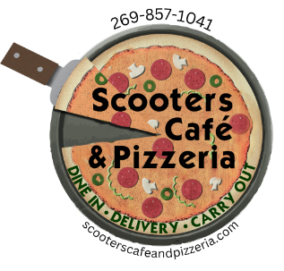

**SCOOTERS CATERING**

**SALAD (SERVES 8-10 PPL)**

**Ceasar -** Romaine lettuce, parmesan cheese, croutons, Ceasar dressing **$40**

**House** - Romaine, spring mix, sliced Roma tomatoes, cucumbers, mozzarella cheese **$40**

**Greek** – Romain, black olives, Roma tomato slices, red onions, feta, cucumber, banana peppers, **$48** pepperoncinis Mediterranean Feta dressing

**Antipasto** – Romaine lettuce, salami, black and green olives, cherry and grape tomatoes, fresh **$55**

Mozzarella, Italian dressing

**Add Chicken** – **($20)**

**PASTA (SERVES 6-8 PPL) $90**

**Penne or Spaghetti (Choose 1) Comes with red sauce or alfredo**

**Add Chicken - $20**

**SANDWICHES**

SM PLATTER (SERVES 8-10) **$60**

LG PLATTER (SERVES 15-20) **$95**

**Italian Deli –** salami, capicola ham, pepperoni, banana peppers, shredded lettuce, provolone,

Italian dressing

**Scooters Club –** ham, turkey, bacon, provolone cheese, shredded lettuce, Roma tomato slices, mayo

**PIZZA - NEW YORK HAND TOSSED (12 INCH)**

**SPECIALTY $23**

**Scooters House Favorite –** Italian sausage, bacon, spinach, mushrooms

**Hawaiian –** ham, bacon, pineapple

**BBQ Chicken –** BBQ sauce, chicken, bacon, red onion, roasted red peppers

**Meat Supreme** - pepperoni, sausage, bacon, capicola ham, salami,

**Veggie** – sliced Roma tomatoes, artichoke hearts, broccolini, sun dried tomatoes, red onions

**CHEESE, PEPPERONI, OR SAUSAGE PIZZA** **$18**

**\*\*\*\* If you would like to substitute any of our other subs or specialty pizzas for what is listed on the catering menu, just call us to discuss. 269-857-1041**

**BEVERAGES**

Individual sodas, iced tea, juice **$3**

2-liter bottles **$7**

Coffee box **$30**

**DESSERTS**

Cookies (ind) **$4** platter (10) **$30**

Brownies (ind) **$3** Platter (10) **$24**